UNIVERSITY OF COPENHAGEN

MOOC Start-up Guide

MOOC Unit
University of Copenhagen
CSS Campus
Øster Farimagsgade 5, building 24.2, PO Box 2099
DK-1014 Copenhagen K
Denmark

Contact:
Anne-Marie Mosbech
anne-marie@sund.ku.dk

What is a MOOC?
A Massive Open Online Course (MOOC) is an online course that is available to anyone for free or at an affordable cost via platforms like Coursera, edX, FutureLearn, and Iversity. All of the University of Copenhagen’s MOOCs are published on Coursera.
If you are not familiar with the MOOC format, it’s a good idea to explore relevant MOOCs before you begin producing one – both those we have produced (coursera.org/UCPH) and relevant courses within your field, produced by other universities across the world.
Once you begin considering to produce a MOOC, you should explore if there are already related MOOCs available, and if so, how your MOOC can make a difference.
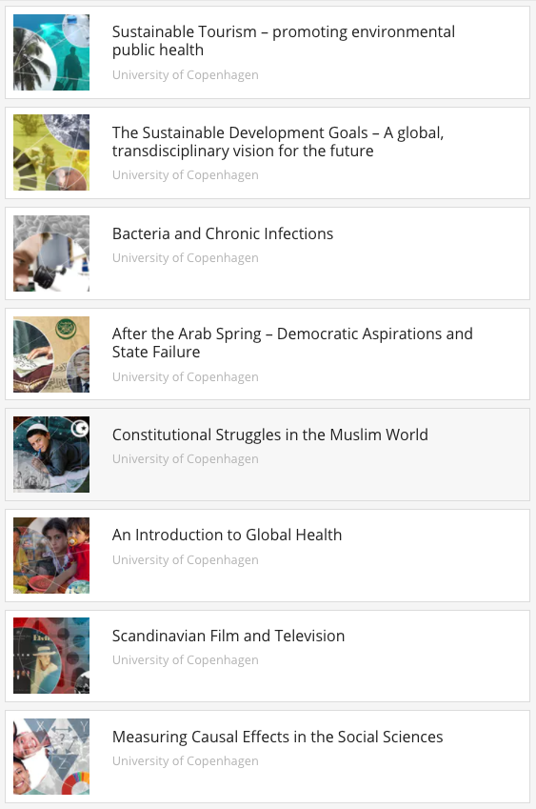
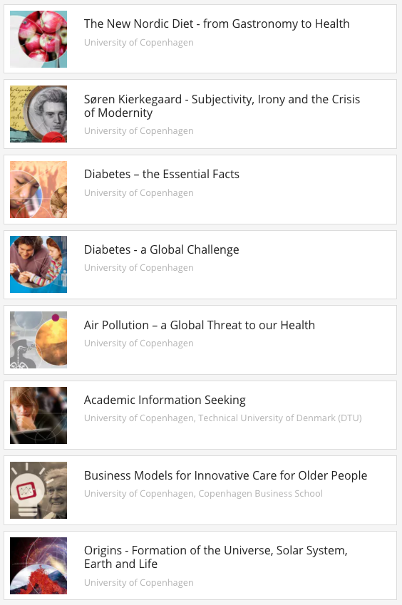

www.coursera.org/ucph
A MOOC typically consists of a mix of self-study materials such as video lectures and readings and learner activities such as quizzes, discussions and peer-reviewed assignments. The duration of MOOCs varies a lot, normally from 3-10 weeks, with an expected weekly workload of 3-6 hours.
At Coursera, MOOCs run in sessions, typically with a new session starting every 4 weeks. This means that a cohort of learners will begin the course simultaneously and go through the course together, week by week. In this way, learners will have classmates to discuss course issues with and peers to review assignments. However, as a learner you can easily race ahead of the course schedule, since all course materials are available as soon as you enroll. If you do so, you might have to wait a bit for responses to your discussion posts and peer-reviews of your assignment as well as your own possibility to review other learners’ assignments. If you fall behind, you can join the next session, and your progress will be transferred. In this way, Coursera can handle the challenge of synchronised activities vs. studying at your own pace quite smoothly.
It is also possible to run a course in a ‘private session’. When doing so, we make a copy of the public course and invite specific learners via email, or we can whitelist certain email domains, which allows any person with a valid email adress from an organisation (or multiple organisations) to join the private session of the course. The course schedule and contents can be customised to fit the specific purpose of the private session, without altering the public version of the course.
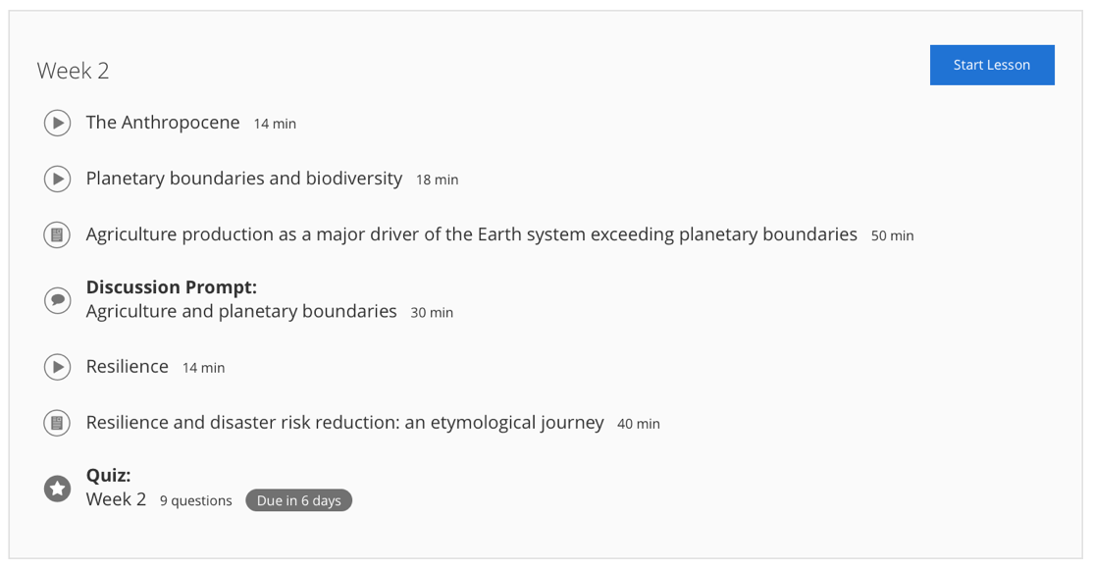
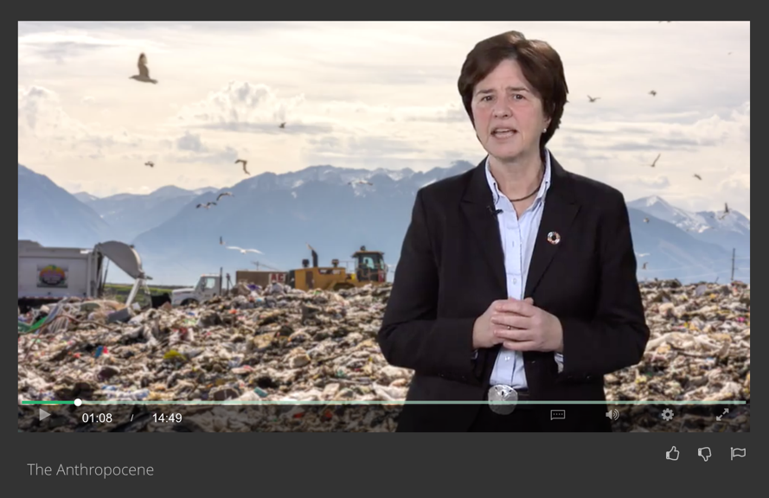
A MOOC can be online as long as it’s relevant.
From MOOC: ‘The Sustainable Development Goals – A global, transdisciplinary vision for the future’
Week 2, video 1: The Anthropocene

The people involved
Producing a MOOC involves many people with different skills: researchers and other specialists, administrative people, and creative people. Most often these people have never worked together before, and often people are spread across several organisational units, and sometimes even institutions and countries. Some are new to the format and the process, while others are new to the subject matter. This means that we have to get a new project organisation up and running very quickly.

The production process
Below you see the main phases of the process. In this Start-up Guide, you will be taken through our recommendations for each phase, with each action assigned to either course responsible(s), lecturers or the MOOC production team. Some tasks require more parties to be involved and some can be carried out by either one alone.
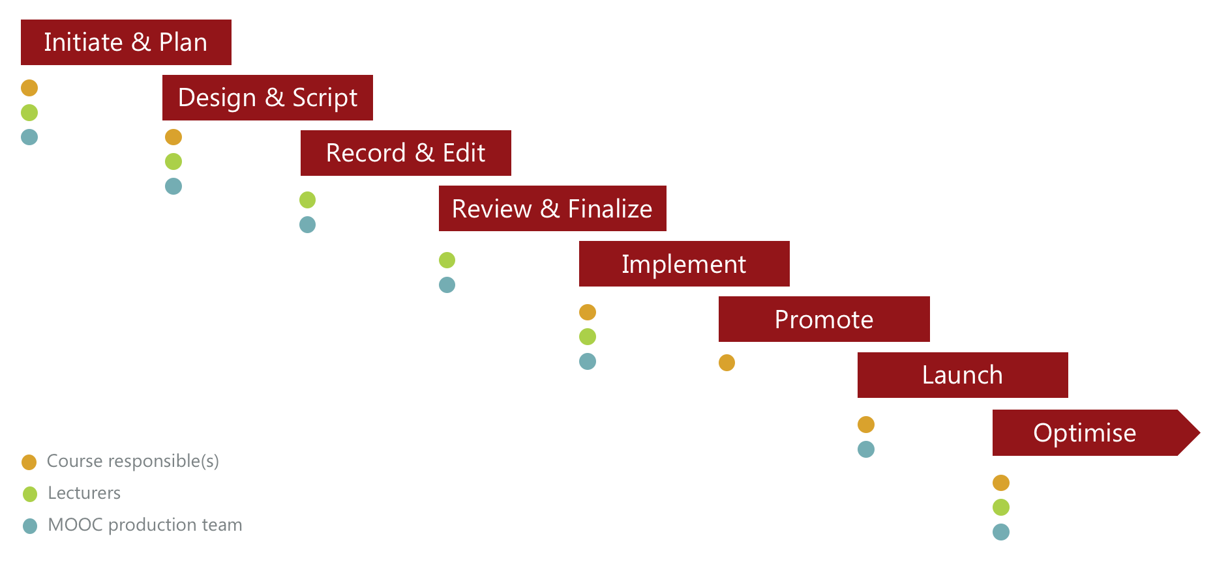
The course responsible(s) will typically be a professor – often assisted by administrative staff, PhD’s or student assistants.
The lecturers are typically university teachers but can also be other types of experts who will deliver content for the course and present their content in video lectures, quizzes, assignments, discussion prompts etc. A course can have one or several lecturers.
The MOOC production team is a team of 2-4 people with the following skills: project management, course design, script writing consultancy, video photographing and editing, and graphic design.
The duration of the MOOC production process is typically 4-8 months, depending on the scale of the course and the number of people involved. The MOOC production team will assist you through all decisions and actions.
This guide is aimed primarily at course responsible(s). However, all lecturers involved in producing content have a key role in the phases: Design & Script, Record & Edit, Review & Finalise – so these sections are primarily aimed at lecturers.

Initiate & Plan
The actions and decisions of the first phase create the foundation for a good online course that will reach the intended learners and learning objectives.
Some decisions may have been settled upfront as part of the agreement for funding, but since the decisions are interdependent, we advise some room for challenging and aligning decisions during the first phases of the production process.
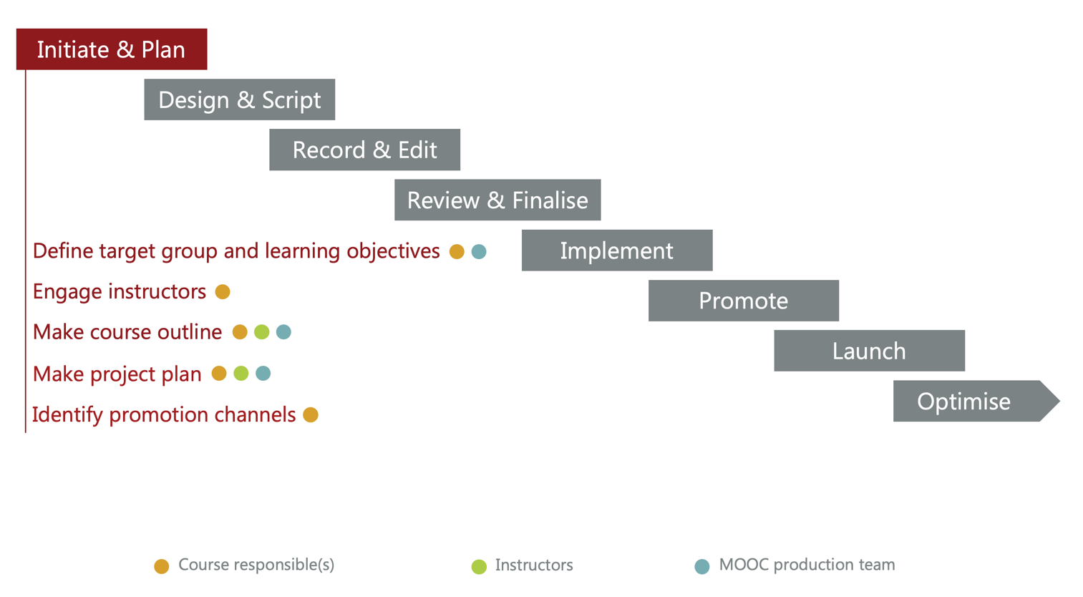

Define target group and learning objectives
Who should be able – or motivated – to do what after having completed the course?
We recommend that you are very specific when describing your learners and what you want to teach them. The more specific, the easier it is to create learning materials that are relevant and motivating for your learners. That said, the audience for an open online course will be very broad. See examples of specific and broad target groups and learning objectives below.
Guides for writing learner-centred objectives:
- https://www.unl.edu/gradstudies/current/teaching/Course_Objectives.pdf
- https://partner.coursera.help/hc/en-us/articles/211693346 (only accessible for Coursera Partners, contact the MOOC Unit for access)

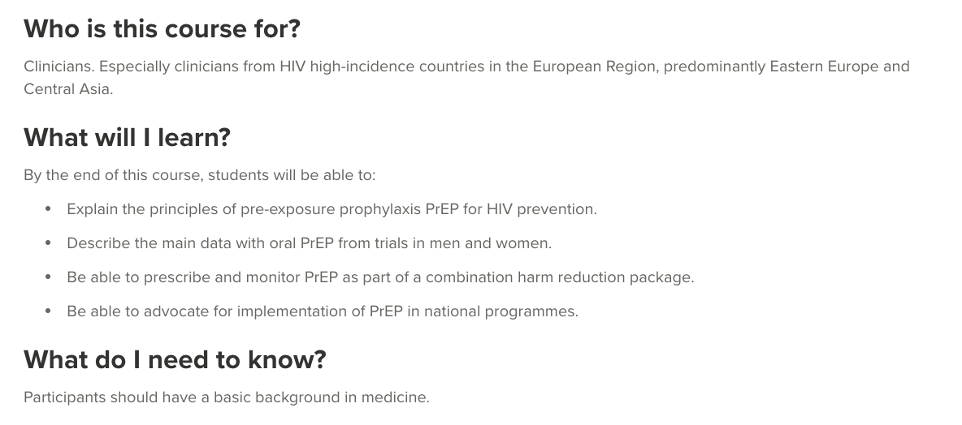
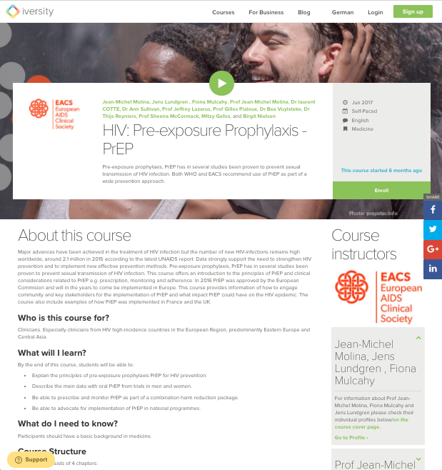
Specific target group and learning objectives:

https://iversity.org/en/courses/hiv-pre-exposure-prophylaxis-prep

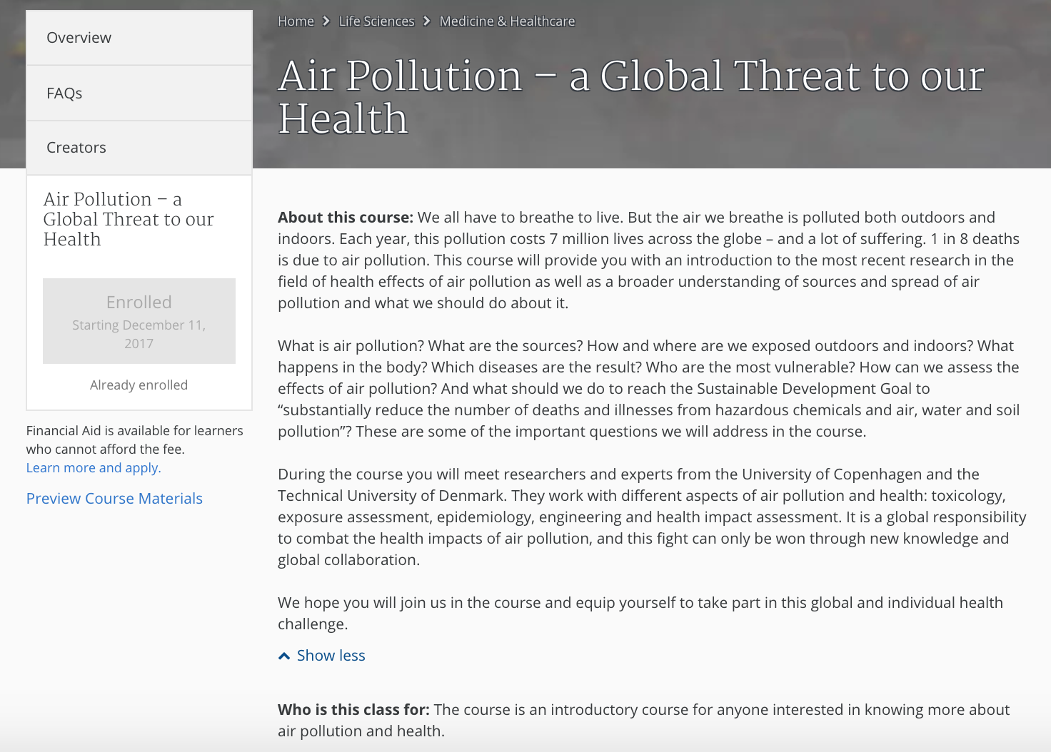
Broader target group. This course has no course-level learning objectives, only module-level learning objectives:

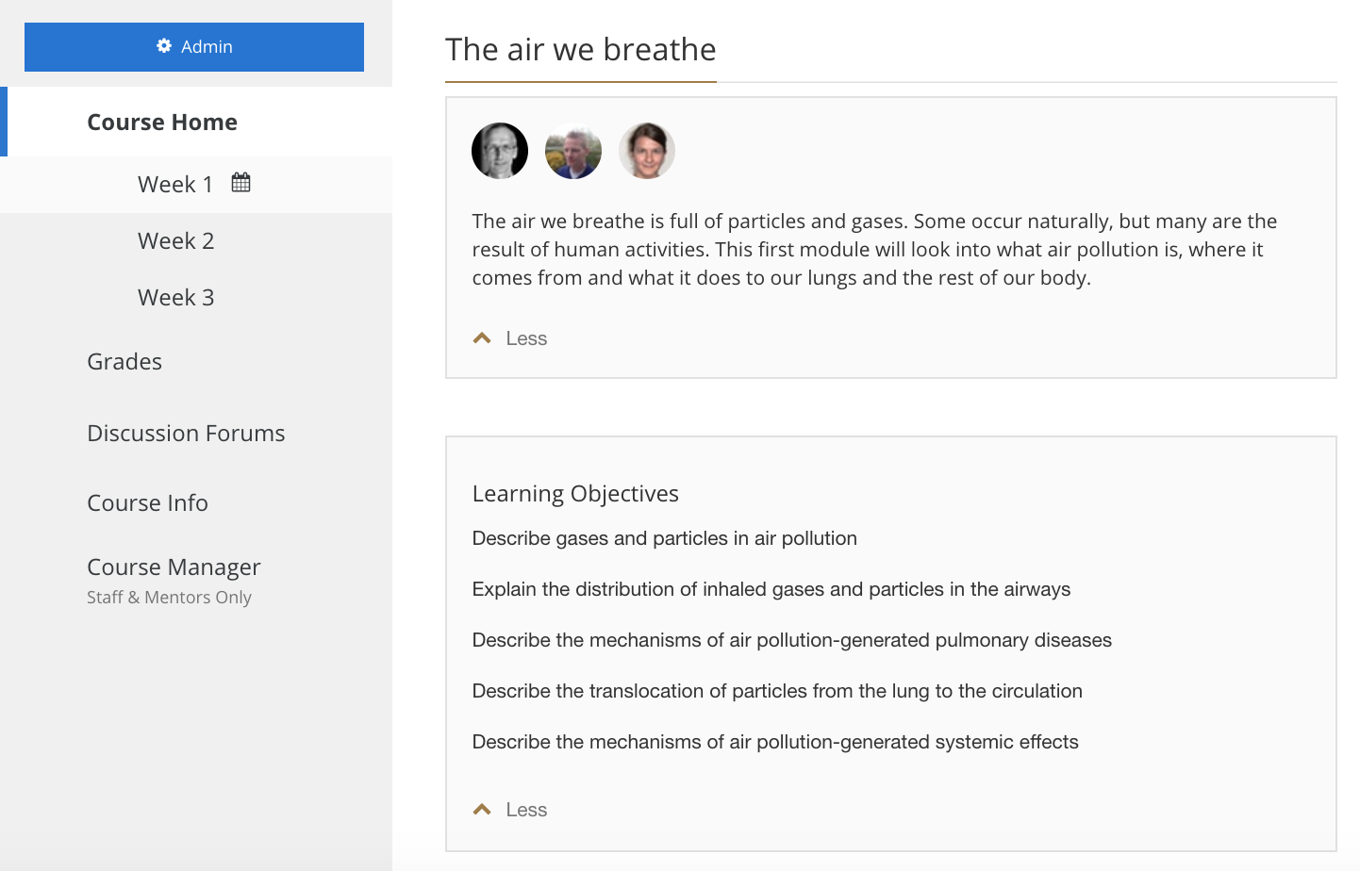

From MOOC: Air Pollution – A Global Threat to our Health

Engage lecturers
Who should deliver content and be teaching the course? How many do you want to engage?
If you involve many lecturers, you can draw on diverse expertise and the workload for each lecturer will be limited – but the need for coordination will be high.
If you involve few, 1-3, lecturers the workload may be somewhat bigger for each person, but the need for coordination will be a lot smaller. You can include additional experts as interviewees in stead of lecturers.
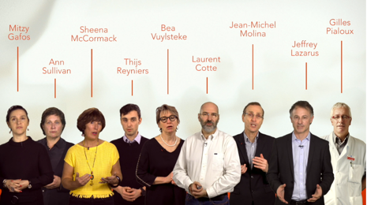 | 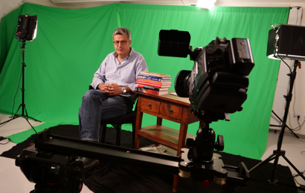 | 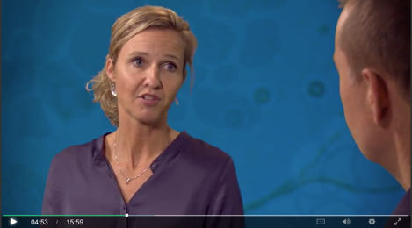
Many? | Few? | Experts as interviewees?

Make course outline
The aim of the course outline is to ensure that the course content will help the learners reach the learning objectives and – very importantly – coordinate content across lectures, in a well-organised structure with progression and no unintended overlaps. In case of many lecturers, the course outline is a very important tool to achieve a good course experience for the learners.
No matter how thoroughly you create the course outline, be prepared to adjust it along the way.
When you create the course outline, we recommend that you start out with ideas for the learning activities you want the students to do: quizzes, assignments, discussions. The reading material and video lectures should then be selected and designed to equip your students to do well in these tasks – and the tasks should of course help the students reach the learning objectives.
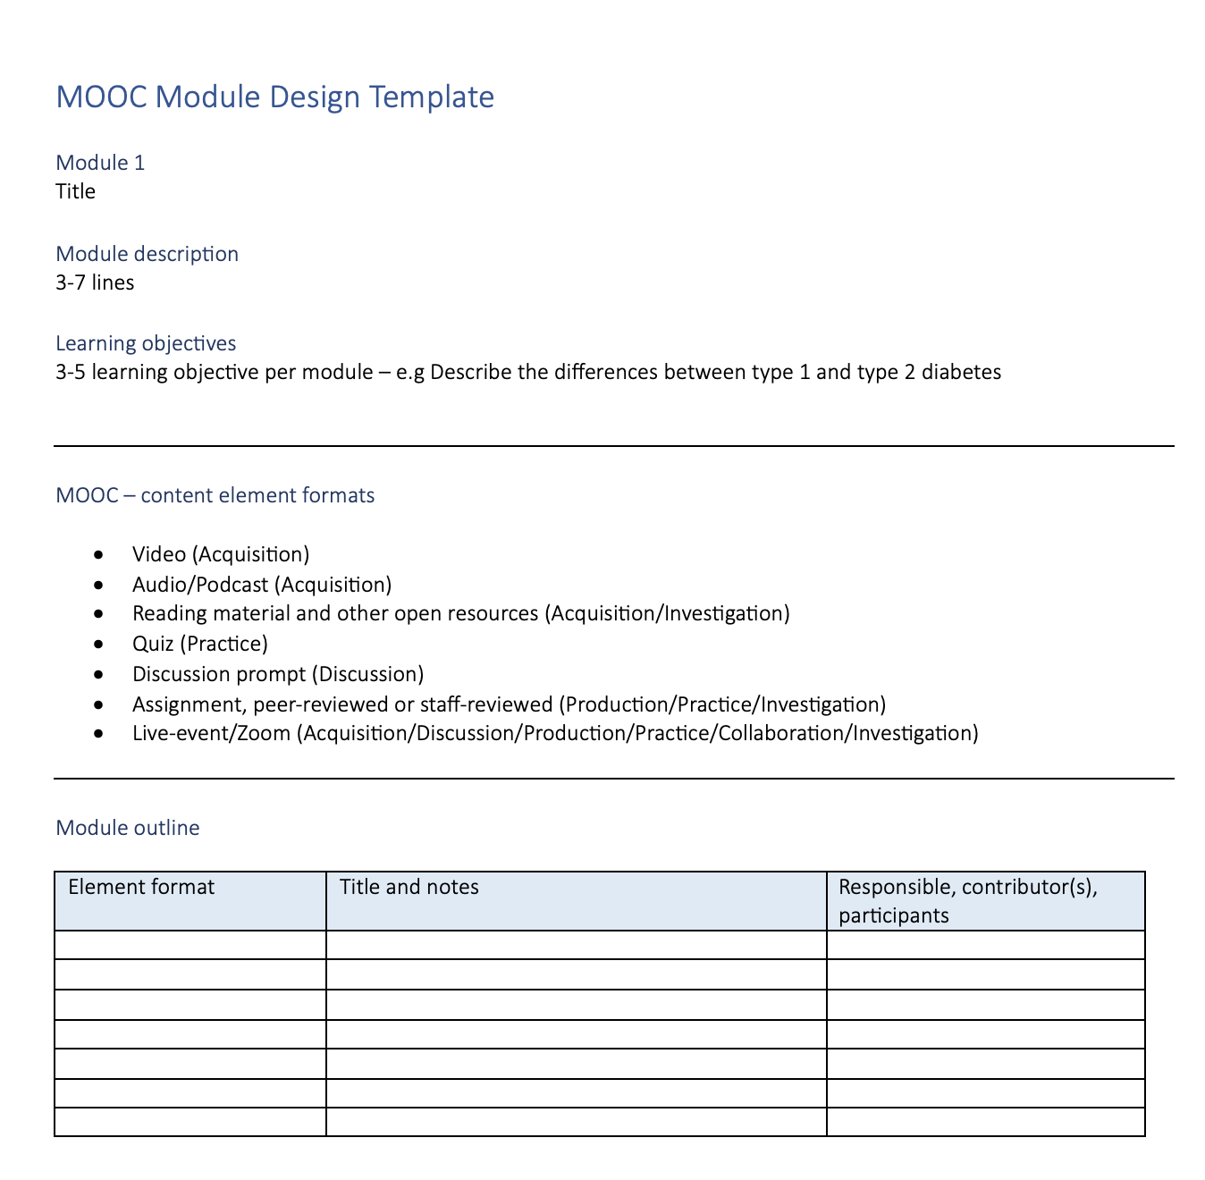

Identify promotion channels
How will your potential learners know about the course? How will you motivate them to enrol?
The MOOC production team can help you create a short, 1-2 minute, video trailer for the course or a visual campaign with images and central questions that will be addressed in the course. The trailer/visuals can be published on relevant websites and distributed on social media and mailing lists and shown at relevant events.

Make project plan
The MOOC production team will make the project plan in close cooperation with the course responsible. It is very important to allow time for reading and reviewing material across all lectures in order to coordinate content once the first version of the material is created. Here is an example from a course with nine lecturers from four European countries developing the content.

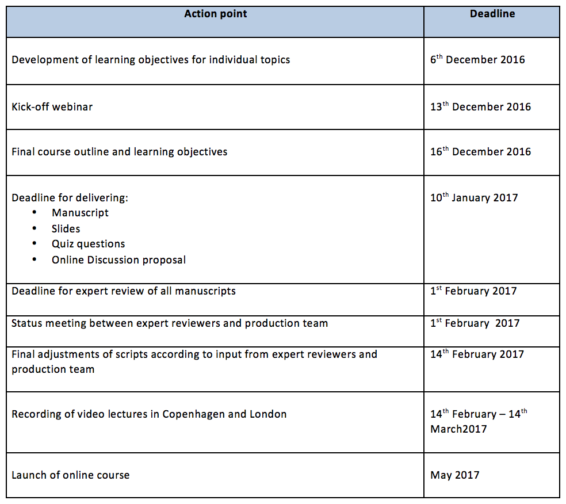

Design & Script
In the Design & Script phase, the lecturers do the main part of their work – so this section of the start-up guide is aimed primarily at the lecturers developing the course content. The course responsible(s) and production team has the important role of ensuring a well-structured course through review, coordination and feedback to lecturers.
When creating content for an online course, most people tend to focus on the script or notes for the video lecture. But as already stated, we would like to help lecturers think differently: Think Learner, Think Activity – before you think My Presentation.
Also, there is no need to produce texts or visual material similar to those that already exist and are publicly available. So this is a good place to start: Find the relevant open access resources that are already out there.
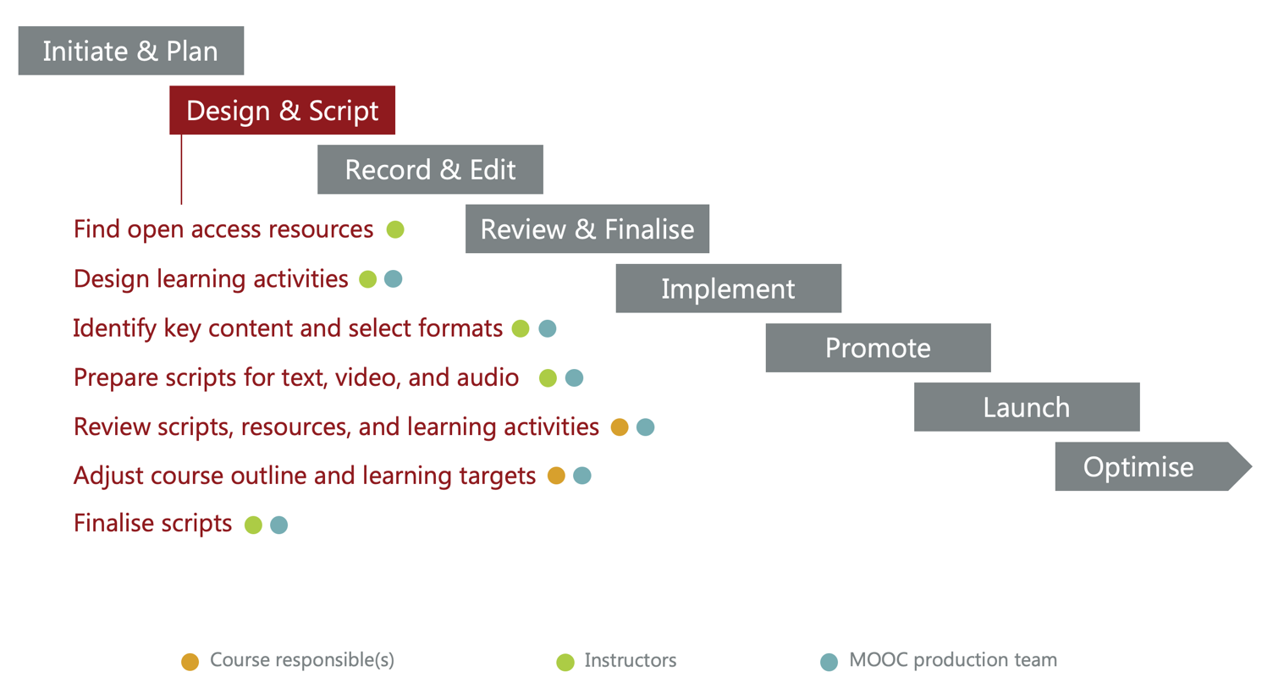

Find open access resources
Open access resources are free, publicly available, online materials like articles, websites, databases, policies, videos, quiz-sets and presentations. Search for relevant material and ask your peers if they know of any great, relevant material. Avoid spending precious time and resources on creating content that is already available.
Referring directly to external materials, and asking your learners to actively use them for assignments, quizzes or discussions is a great way of linking the course content to real-life challenges and solutions.
You can also build upon such material in your own lectures or you can use it as ‘further reading’.

Design learner activities
Activating learners around central course material is essential for the learning outcome and for the learner’s ability to assess his/her learning progress. In MOOCS however, the number of students and the constant flow of assignments makes it impossible for lecturers to evaluate or grade students’ work. The solution is to use quizzes (maybe with pre-edited feedback), discussion prompts and peer-graded assignments.

Quizzes
We recommend to have at least 3-5 quiz questions pr. video/audio/text element that is produced for the course. Quiz questions can also be related to articles, research in databases, etc. Quizzes are most often graded and mandatory for completing the course. Questions can have pre-edited feedback as shown below to the right. Quizzes can be presented to the learner immediately after a content element or as a module test at the end of a module with a number of content elements.
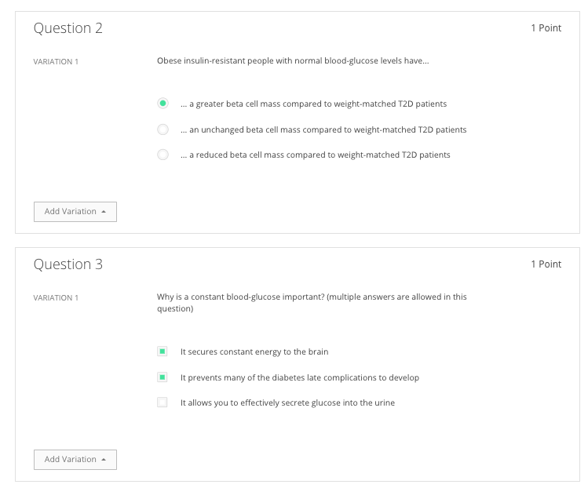
Find guidance for writing good quiz questions here: https://cft.vanderbilt.edu/guides-sub-pages/writing-good-multiple-choice-test-questions/

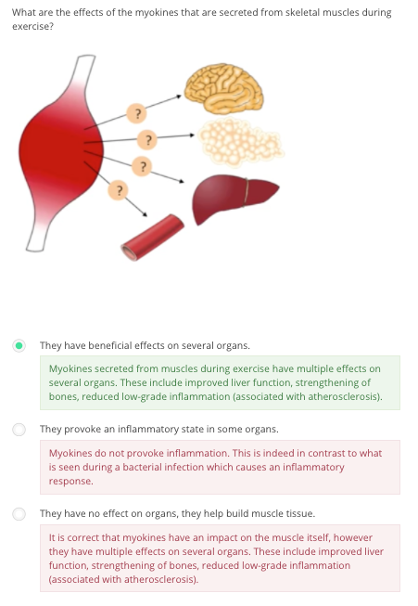
From MOOC: Diabetes – A Global challenge

Discussion prompts
A discussion prompt is a great way of engaging your global audience of learners in interesting discussions. Based on specific course content or relevant, related material, you can frame a discussion by stating a few good questions that can spark a global discussion or sharing of experiences and views.
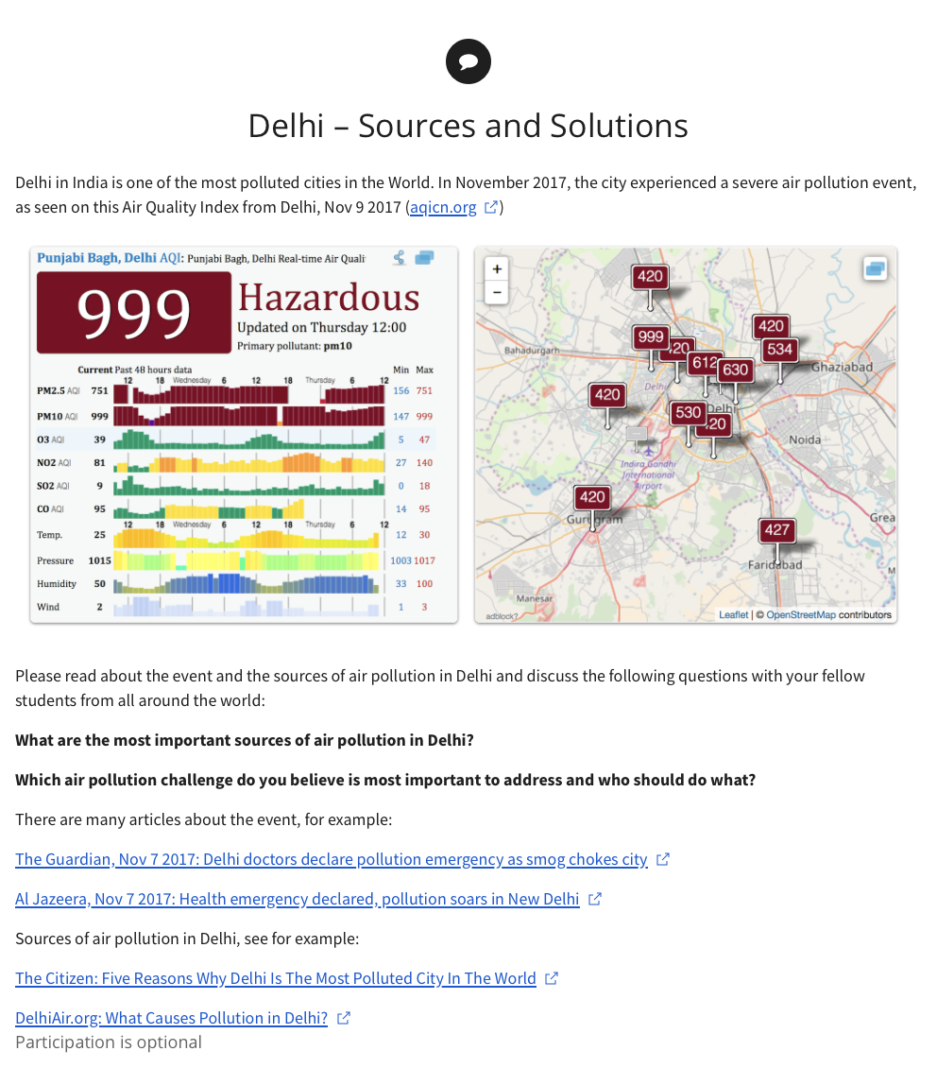
From MOOC: Air Pollution – A Global Threat to our Health

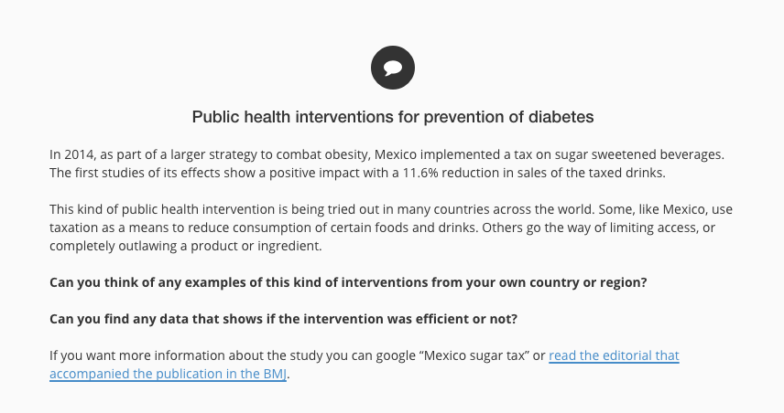

From MOOC: Diabetes – The essential facts

Peer-graded assignments

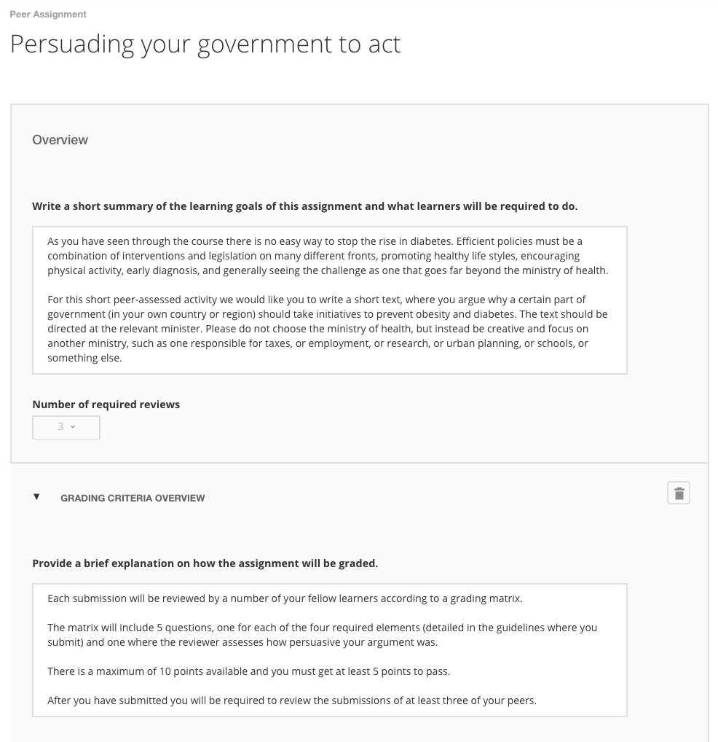
Peer graded assignments let the learner engage more deeply with the content – and students learn a lot from evaluating each other’s work. Be aware of describing well-defined review criteria to avoid confusion and frustrations among the learners.

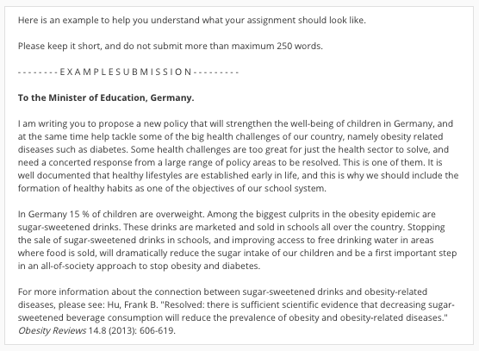
Review criteria are defined in rubrics:

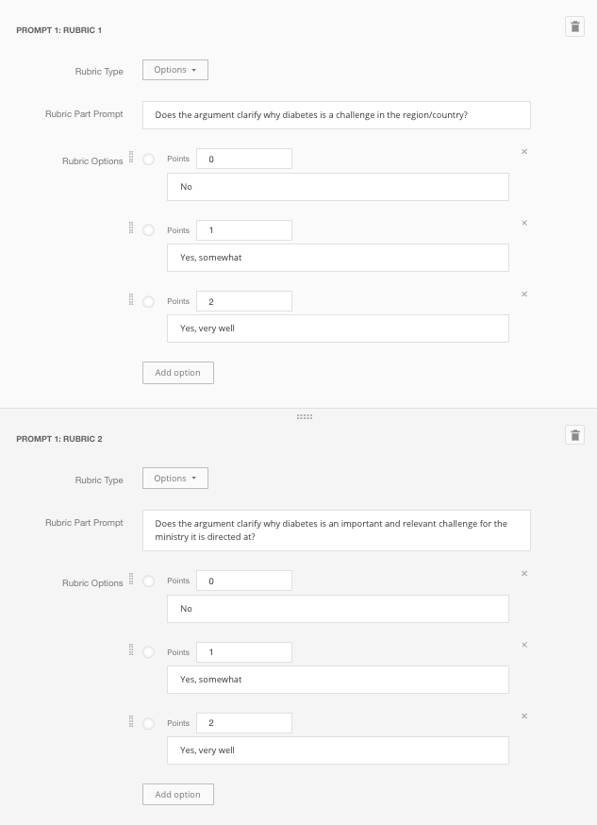

From MOOC: Diabetes – The essential facts

Identify key content to produce and select formats
Once you have a well-defined target group and draft versions of the course outline, your learning objectives, quiz questions (and perhaps discussion and/or assignment prompts) and you have identified relevant open access resources, you should identify the key content that must be produced for the course or module.
So far, most online courses have been based primarily on educational videos in combination with reading material and learning activities, such as quizzes, discussions and assignments. The podcast-format is becoming more and more popular, especially among younger generations – and even though the Coursera platform does not yet support this format, many younger learners are listening to the videos in stead of watching them.
We aim at creating videos only when the content is visual and the video format adds educational value. Some content is best suited for reading (maybe enriched with still graphics), some content is well-suited for listening, for example interesting discussions between experts or case stories from people with relevant experiences to tell about.
The MOOC production team can help you organise the content and select the format that is best suited for each piece of content.

Prepare scripts for text, video and audio (podcast)

Text-format (pdf-files)
If you have content that is best suited for the text-format (maybe illustrated with still graphics), and you cannot find suitable articles or other accessible material, you can write such text-book-like material and provide it for the learners in a pdf-file or as a text page on Coursera. The MOOC production team can review the text for clarity and alignment with learning objectives and learning activities, and also help with graphics and layout.

Prepare video or audio recordning
Preparations for a video or audio recording differ greatly depending on what the content is. On the following pages, you will find brief guidance for preparing:
- On-location video/audio (e.g. clinical settings, patients/citizens at home/in local communities, or other relevant locations)
- Video/audio interview or round-table talks with experts, patients, or other relevant people
- Slide-based video lecture

On-location video/audio
The MOOC Production team will help you prepare for on-location recording. To get started write down the key messages you want to give and the people/things/procedures you want to show or audio-record.
Often, we will do the on-location recordings based on an initial script, and then, after the recordings are done and roughly edited, we will finalise the script for a narrator/voice over to tie the scenes together.
If the content is an acted scenario, you can write a filmic script like the example shown below (maybe with help from the production team):
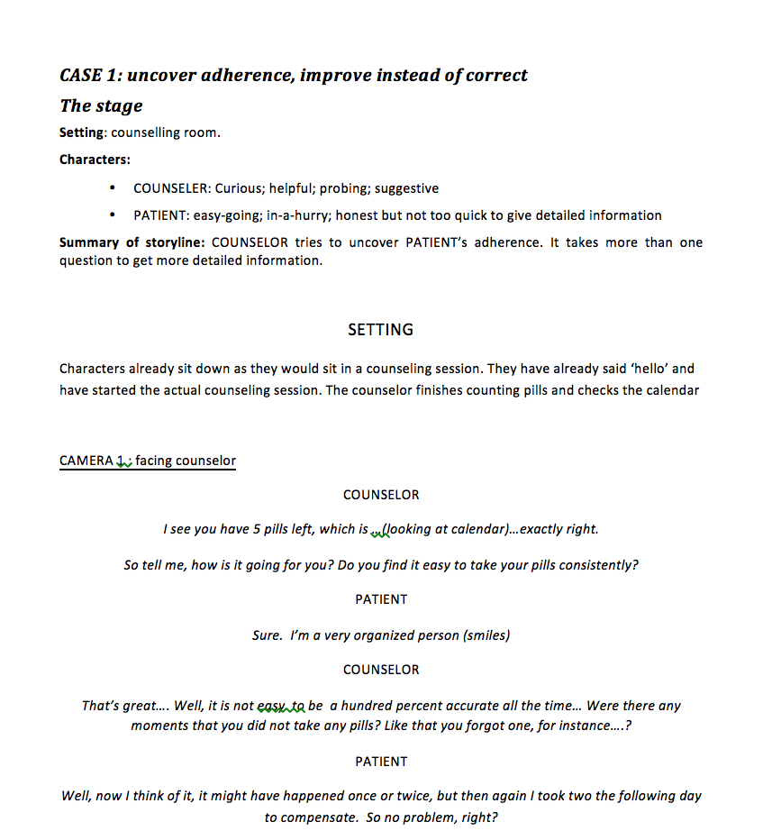
https://iversity.org/en/courses/hiv-pre-exposure-prophylaxis-prep

On-location shooting often requires coordination between several people and places – but the resulting content will most likely be highly valuable for the learning experience!

Video/audio interview or round-table talks
For interviews you should prepare the questions you want to ask each participant in the interview. The MOOC production team can do the interview based on your questions, or you can take the role of the interviewer yourself, depending on what you prefer. It might make sense to record the interview as a conversation between experts, where we see both interviewer and interviewee. Alternatively, we will only see the interviewee’s statements, and the interviewer and the questions posed will not be part of the final video.
For both interviews and round-table talks, the MOOC production team will help you prepare a good interview guide and prepare the participants for the recording.
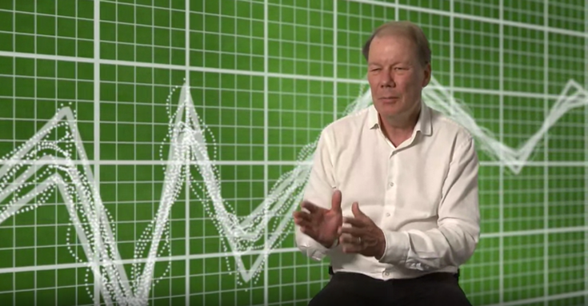  Interviewer invisible (greenscreen recording + graphics)  From MOOC: Personalised Medicine from a Nordic Perspective  Week 2, video 1: Mapping disease trajectories from longitudinal health data – Søren Brunak |  | 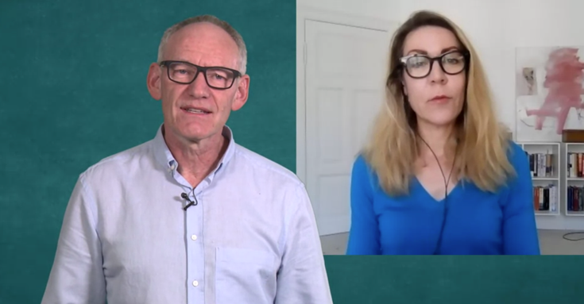  Expert interviewer in studio, another expert online  From MOOC: Personalised Medicine from a Nordic Perspective  Week 5, video 5: Media hype and horror – Hakon Heimer, Lone Frank, Heidi bentzen
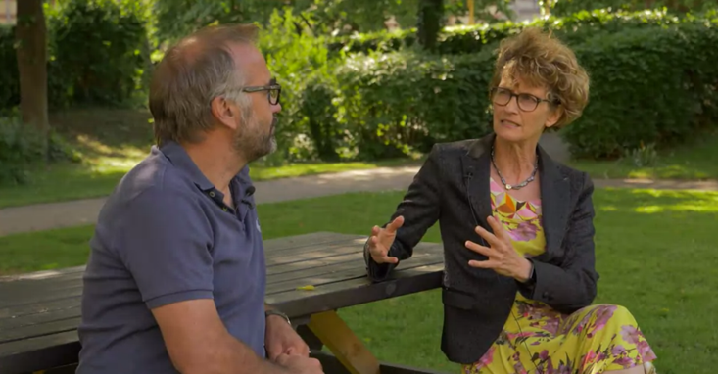  Conversation between experts  From MOOC: Personalised Medicine from a Nordic Perspective  Week 4, video 2: Novel trials to generate evidence – Merete Lund Hetland, Anders Perner |  | 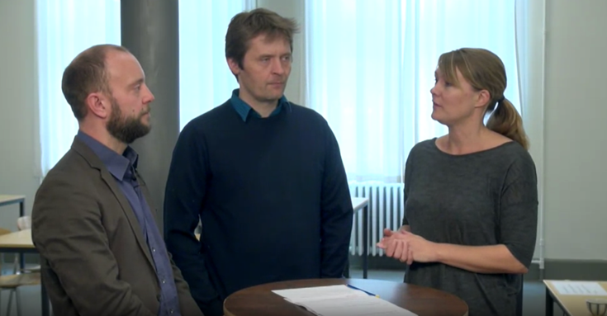  Round-table talk  From MOOC: Bacteria and Chronic Infections  Week 6, video 4: Adaptation and evolution in bacteria – Interview with Mette Burmølle and Lars Jelsbak

Slide-based video lecture
If you are preparing the script for a ‘classical’ slide-based video lecture, we recommend that you first search for good visuals that will help you show your key points and tell your story. Idealy, you should build your presentation around central visual material such as interesting data visualisations, a good illustration of causes and effects, or photo or video from relevant places.
If relevant, you can bring objects to the studio – for example a geological sample or medical equipment – for “show and tell”.
The MOOC production team will aim to create a uniform graphical look across the course lectures. This means that you do not need to think about how your slides or drafts for illustrations look. However, you have to give specific descriptions of what you want to illustrate. You can provide your visuals in the highest possible resolution in a slide-format (PowerPoint, Keynote etc.)
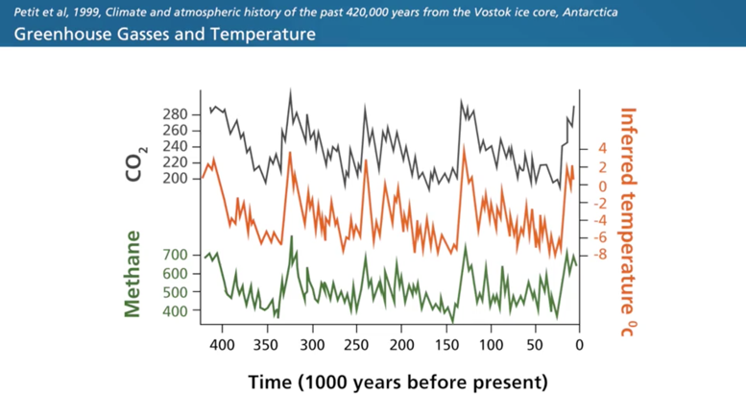
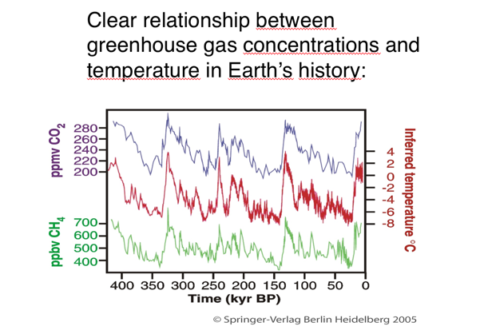

If you have some visual ideas, but no visual material, you can describe your ideas on a slide and refer to it in the script. You can also note if you would like our graphic designer to make a certain illustration – but be aware that we have limited resources for producing tailor-made graphics. Often we will have to use the visuals you provide.
For visuals found on the internet, be aware of copyrights! On Google, you can search for images that are free to use:
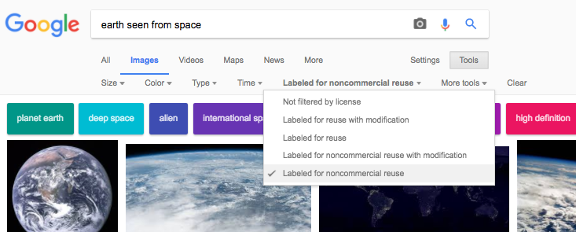
Find guidance about legal use of visual material in education here: http://undervislovligt.dk/?lang=en
You may ask: Is it necessary to write a full script? Why can’t I talk from my notes and slides like I’m used to in class?
Making a video lecture is very different from presenting a lecture in front of a class. The camera gives no feedback – what so ever. You will have to make the lecture “come alive” without an audience. A written manuscript will help you:
- write a text that is precise and well-structured
- get feedback on your presentation from peers and video lecture specialists
- ensure that graphs, illustrations, etc. are clearly explained for your global audience
- say exactly what you have planned at the recording session: you will read from at teleprompter, and this will help you avoid making mistakes or getting unclear along the way

Tips for writing a good script:
- You can open the video lecture in different ways, but no matter how you do it, you should try to catch the attention of your audience from the very beginning. Here are a few ideas: Present the essence of the video in a few lines, through a case study or an example of what the content means in a broader context. Why is your lecture relevant? Avoid abstract and difficult academic terms in the introduction. Keep it simple and explain in layman terms. You can elaborate afterwards.
- You can give a brief introduction of yourself (name, title, specialization). But in many cases, a text box showing your name and title in the beginning will be sufficient.
- Think visually. As stated above, the video format is good for “show-and-tell”. Let your script grow from the visuals you want to present, e.g. photos, video clips, graphs, illustrations. Also consider if you have any objects you can show in the lecture.
- Consider if you know of any cases or examples that are suitable to communicate your topic. Cases are great for visualizing theories and unfolding statistics.
- You may consider including an interview with an expert or relevant citizen to make the subject more personal and relevant to the audience. It may add an extra dimension to the theory.
- Write in a direct spoken language as if you were talking directly to a student in front of you. This may help to avoid long and complex sentences.
- Read the text out loud to yourself or others to ensure the text has a good flow. Reading silently isn’t enough. Change sentences if you stumble upon them:
- make them shorter
- spell out abbreviations
- name only the absolutely necessary figures and numbers – we can show them on screen in stead
- change passive verbs into actives and replace gerunds with verbs and nouns
- name yourself “I” and not “we”.
- Keep the duration in mind: 500 words is approximately 4 minutes of talk.
- The specific format for writing scripts can vary. The important thing is to have a clear connection between the spoken words and the visual side. See an example on the next page.
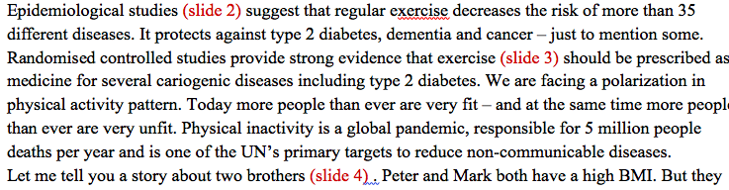
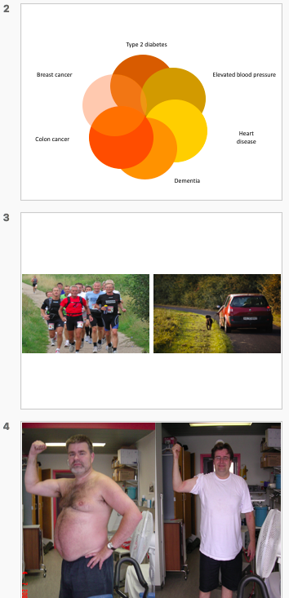
See the final video in the MOOC: Diabetes – A Global Challenge
Week 11, video 1: Physical Inactivity – a Major Risk Factor for Diabetes (time code 01:37)

Review scripts, resources, and learning activities
A few people – at least one course responsible and one from the production team – should take the time to read across all materials, coordinate content, remove overlaps, identify gaps, and change order of materials to make the best possible learning flow. This is especially important if many lecturers are involved.

Adjust course outline and learning objectives
As stated before, be willing to adjust the course outline and sharpen learning objectives at this stage in order to optimize the learning experience now that the content is much more clear and elaborated.

Finalise script
The people reviewing all the course material must give feedback to each lecturer and maybe ask two lecturers to coordinate content between them. When finalizing the script, it is important to read video/audio scripts out loud, to optimise them for the recording session.

Record & Edit

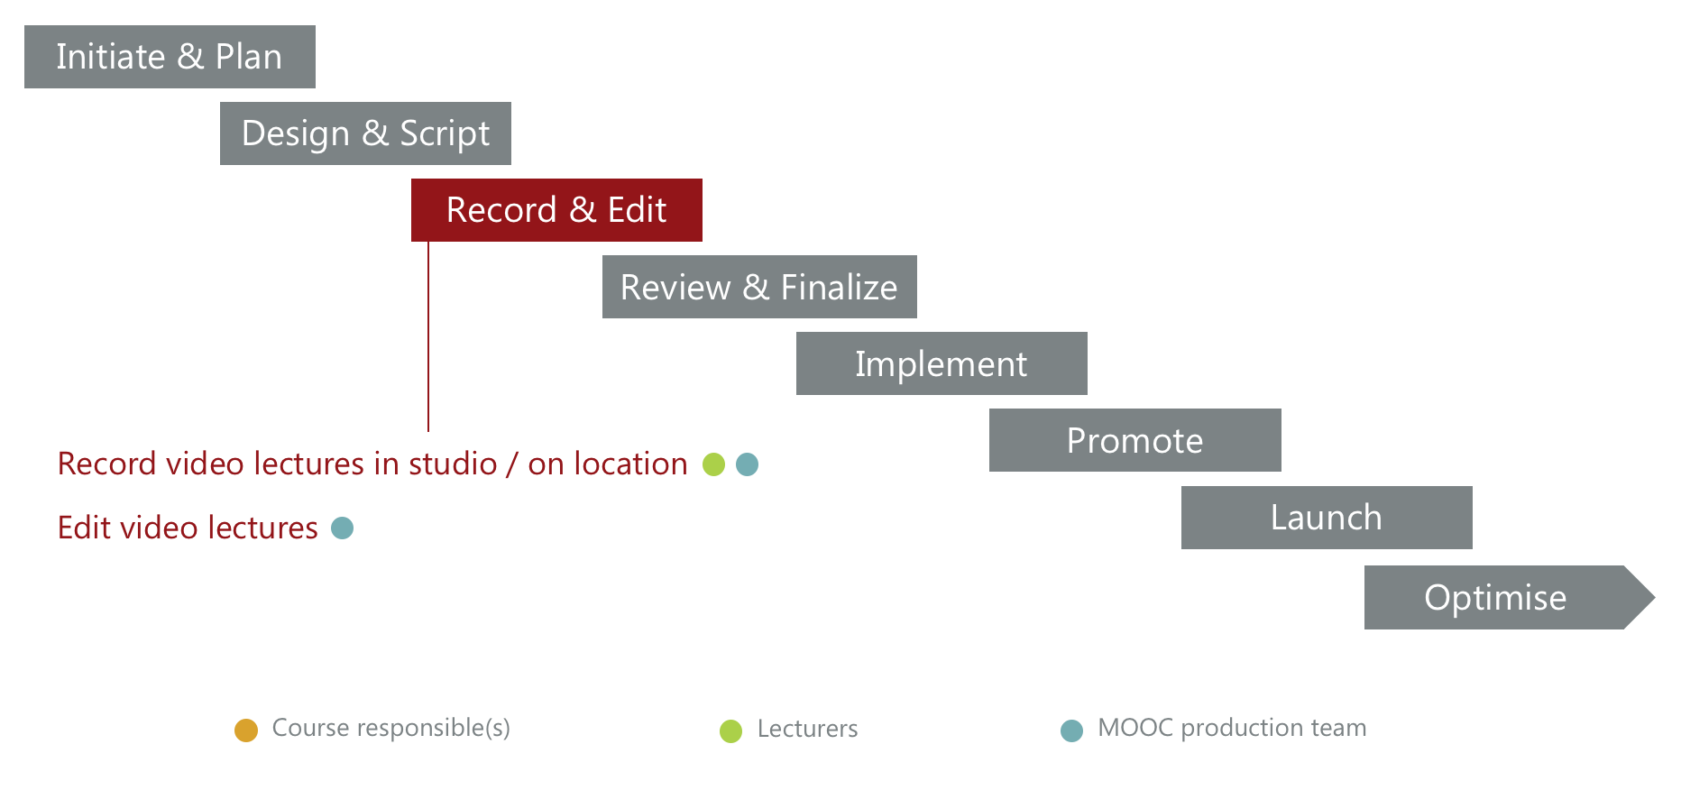

Record videos
Many video lectures are shot in the MOOC Unit studio with a green screen background, which can be replaced by relevant images during editing. But sometimes it makes sense to go to a specific location to show something specific or to be in a surrounding relevant for the content. No matter where the shooting takes place, it is important that we can work with as few interruptions by e.g. noisy surroundings as possible.
If many lecturers from different countries are involved, it may be a good idea to plan recordings in relation to a conference or another event where they are gathered anyway. We have a mobile green screen studio set-up, so all we need is a quiet room with acceptable acoustics.
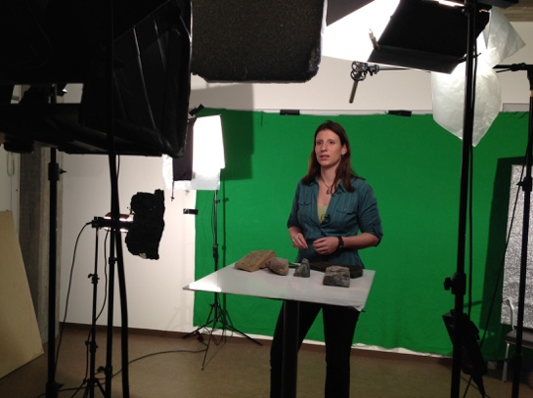 | 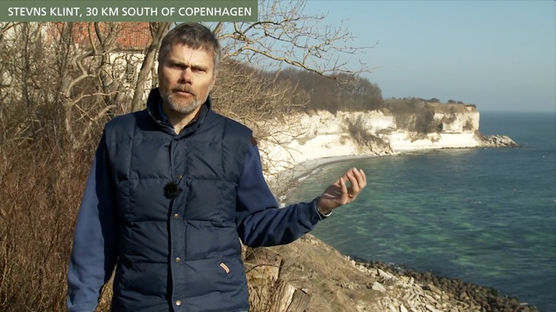
During the shooting, you will read your script from a teleprompter placed in front of the camera lens. The text is rolling and you can pause/play as you wish. Note that all paragraphs and bullet lists will be removed. Therefore, you should be familiar with the text so that you can place small pauses where it is appropriate and use a convincing and enthusiastic tone of voice.
You should tell the text rather than read it!
If you have an iPad, you can download a teleprompter software that is often used by video producers. One app is called “dv Prompter”. Paste your text into the software, play it and experience how much of the text you can see at a time, the rolling speed, font size etc. In the studio, you will be reading the text from approximately 3 meters. If you want to try this, you need to remove all bullets and formatting from your text.
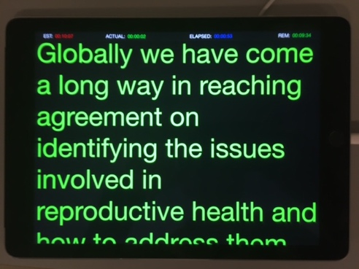

Being in front of the camera
If you are in front of the camera for the first time, it may take a little while to get used to the experience. Once you have had a chance to speak to the camera and get warmed up, it is often best to treat the shoot as if it were live, meaning: do not worry about getting things completely perfect. Your students are out there, and they will not notice the occasional stumble if they are following your story. For the sake of image framing you have to keep your feet on a specific spot, but please feel free to change weight from one foot to the other and to gesture with your hands. This will make the video more vivid.

Bring relevant objects
Remember to bring relevant objects (according to your manuscript) that you would like to show the students, while shooting the video.

Clothing
Please avoid white, checkered, striped and very shiny clothes. And if the shooting will take place in a green screen studio, please also avoid green clothes - it will make you invisible.

Online recording
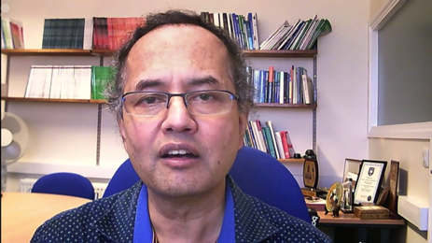
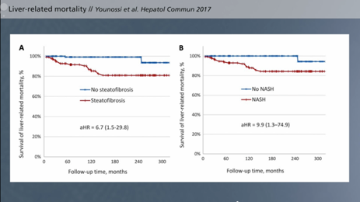
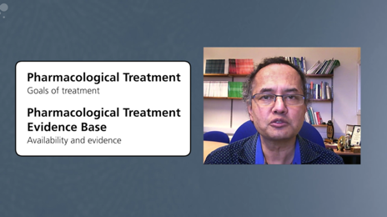
It is also possible to record video lectures online, e.g. using Zoom or Skype. In that case you will not read from a teleprompter and not be filmed on a green screen. The MOOC production team can provide guidance regarding the technical setup.

Edit videos
The MOOC production team will edit the videos based on a design guide, which must be approved by the course responsible before the editing begins.
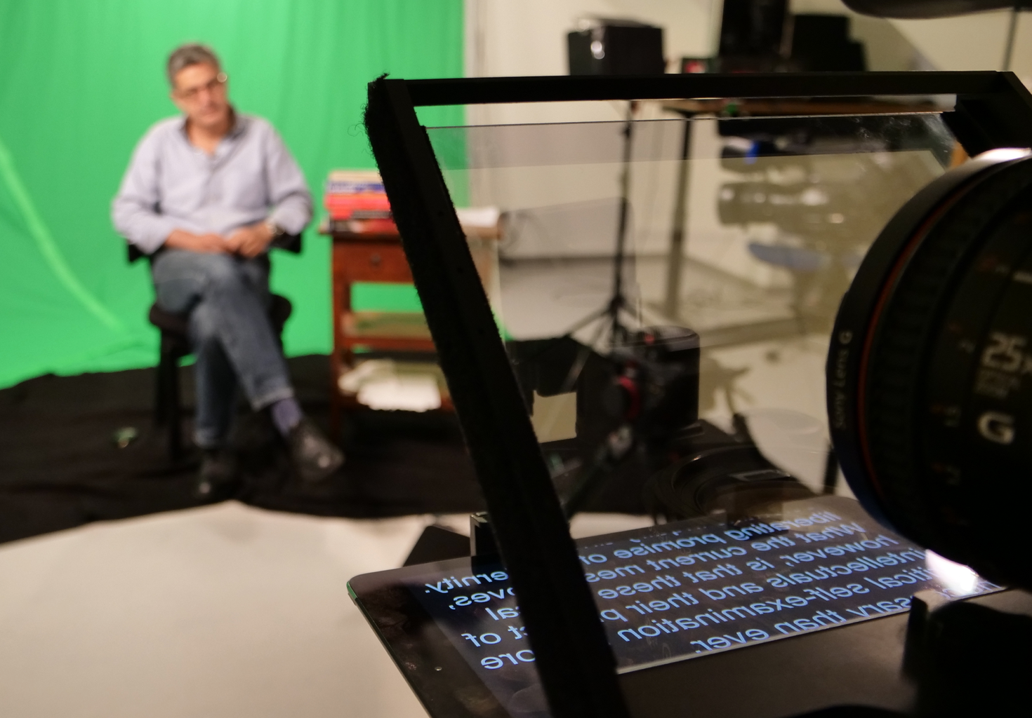

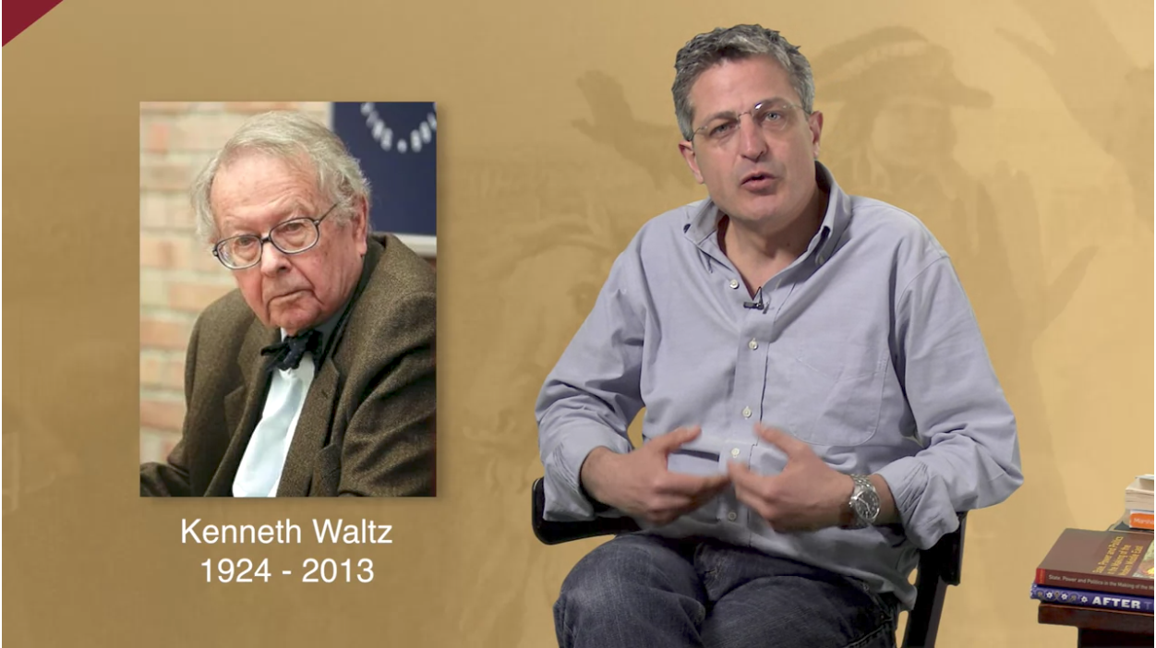
20

21
Show prep

From MOOC: After the Arab Spring – Democratic Aspirations and State Failure

Review & Finalise
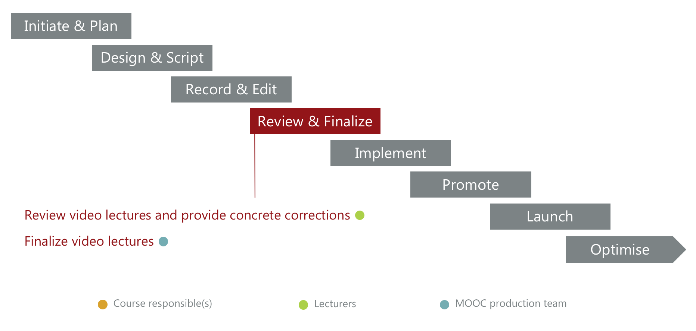

Review video lectures
When the video is ready for review, the lecturer will receive a mail with instructions for the review, link to the video, and a review document:
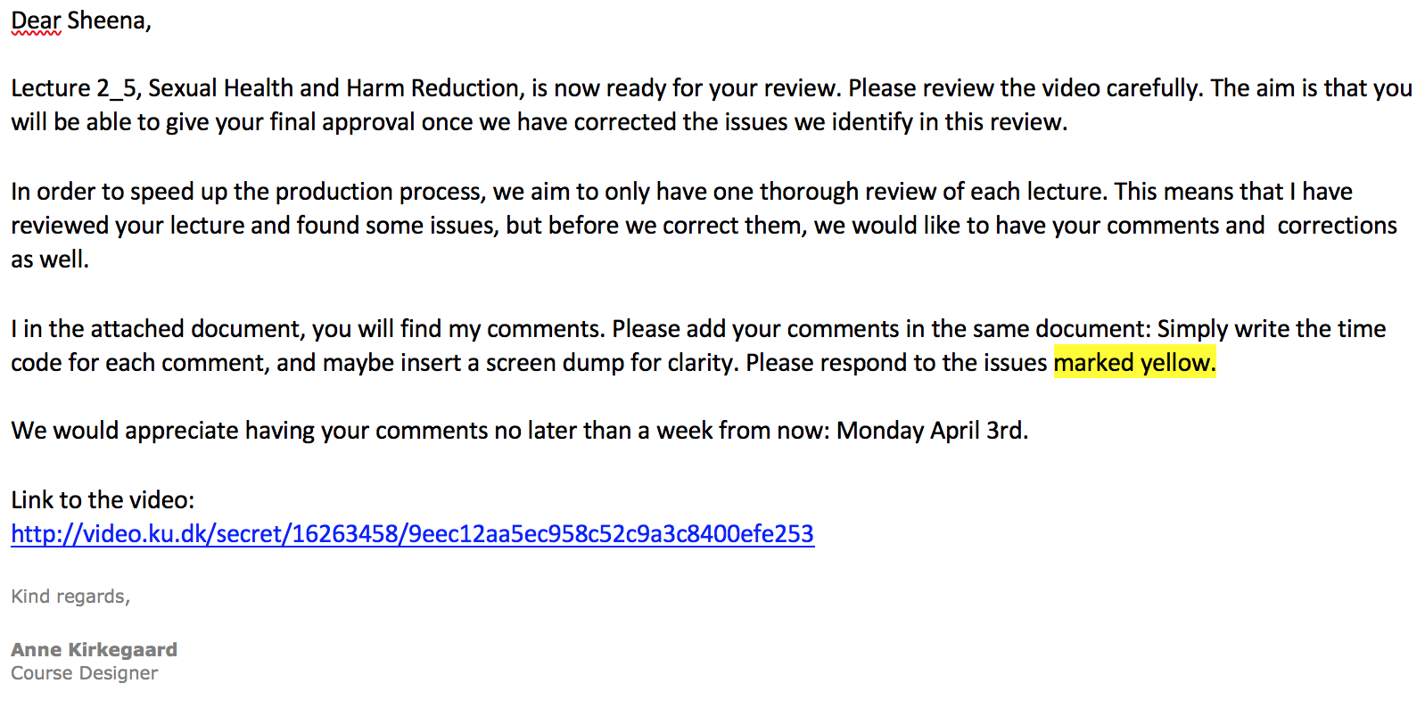

When reporting issues, it is important to be very specific, since we all want to avoid numerous rounds of editing and reviewing.
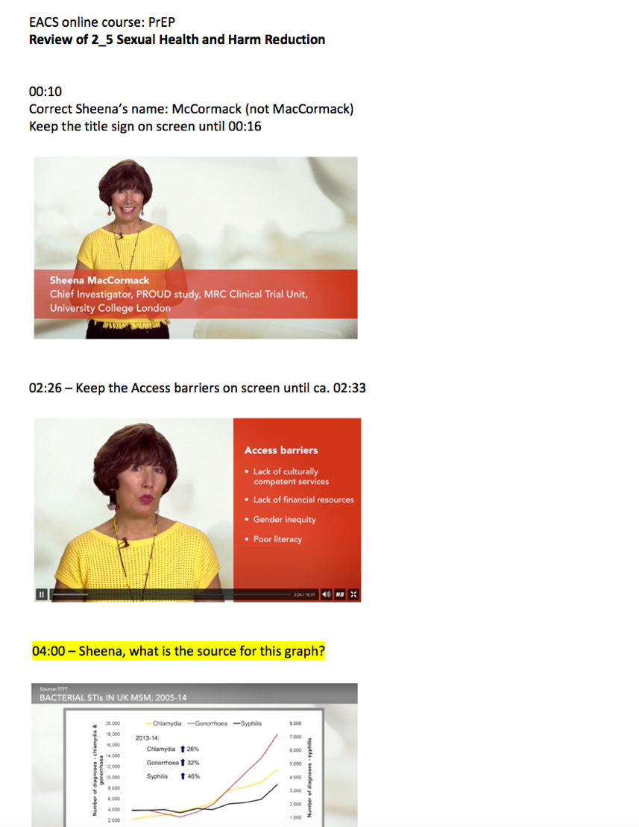

Finalise video lectures
The MOOC production team will do the final editing based on the review document received from the lecturer end then send the video lecture for approval. The aim is to have only one review before we can reach approval.

Implement

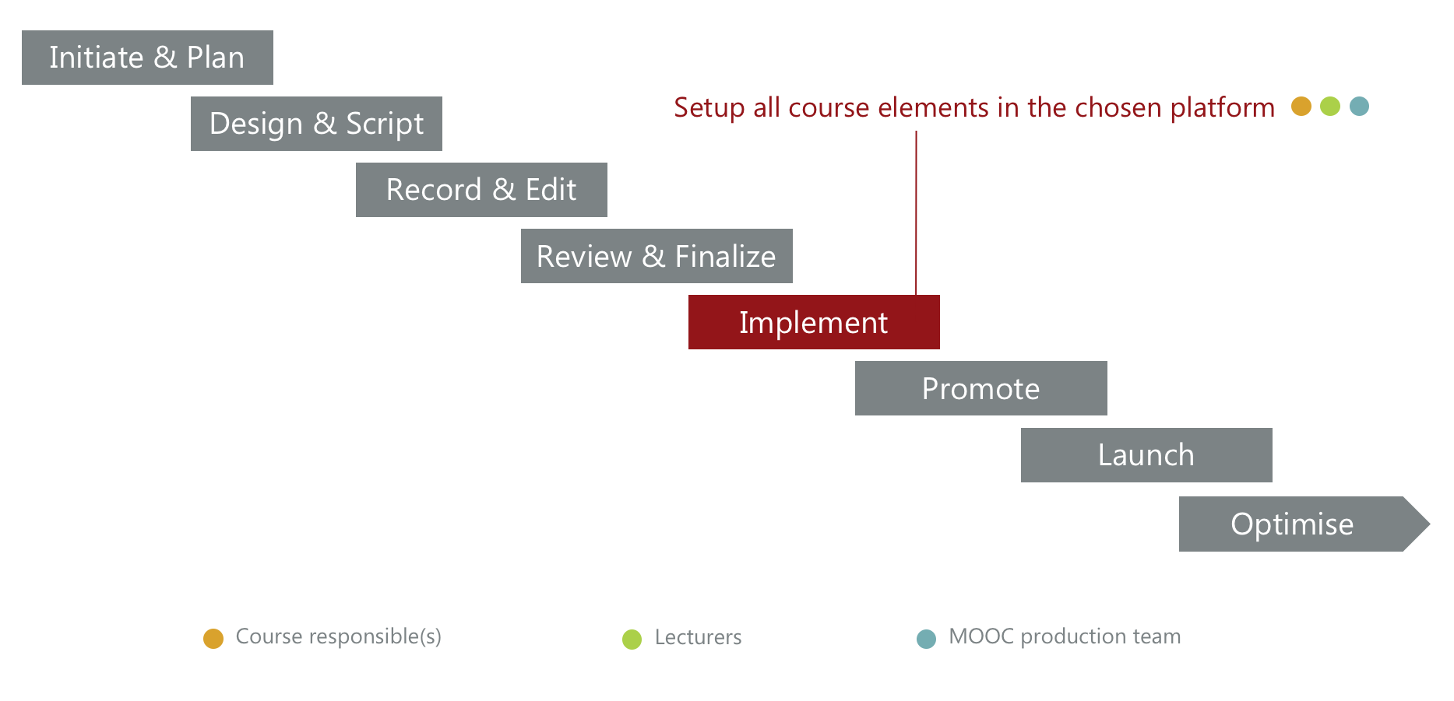

Normally, the MOOC production team will implement all course elements on Coursera. However, sometimes it may make sense that the course responsible(s) take on this task: especially if you want to be able to monitor learner activity and adjust texts, quizzes, discussion prompts and assignments based on learner feedback. In that case, the MOOC production team will assist in the implementation process as needed.
Implementation of all course elements must be finalised at least 1 week before course launch to allow the mandatory review done by Coursera.
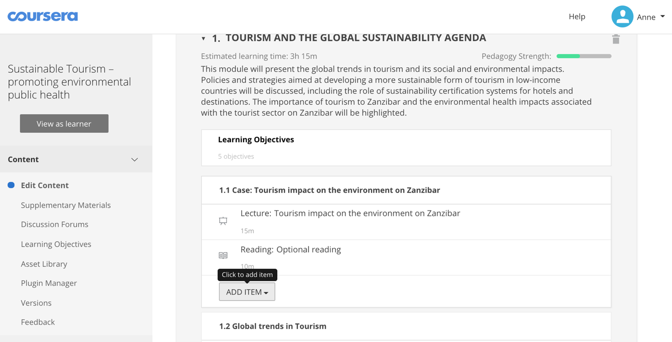

Promote
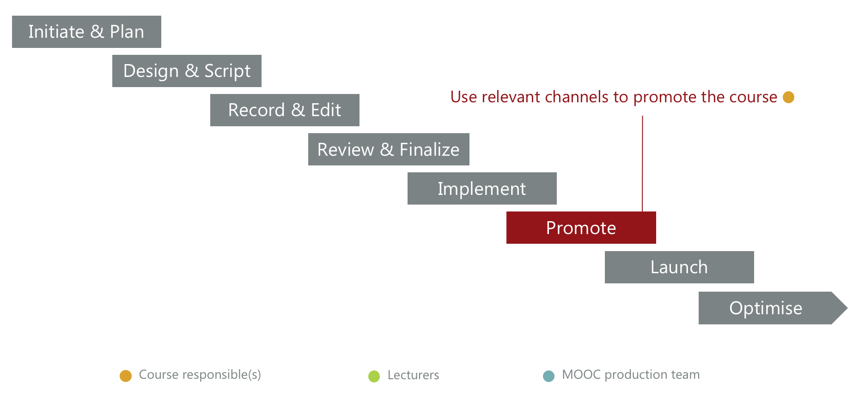
About 2 weeks before course launch, we can open the course for pre-enrollment.

This means that people will be able to see a course description and check out the teacher profiles – and pre-enroll. Once a learner is enrolled, he will receive email reminders about the course activities – when the course launches and when it’s time to complete quizzes and other graded work.

When the course is open for pre-enrollment, it is time for the course responsible(s) to begin the planned promoting activities: sharing the trailer or visual campaign material on social media, mailing lists, relevant websites etc.

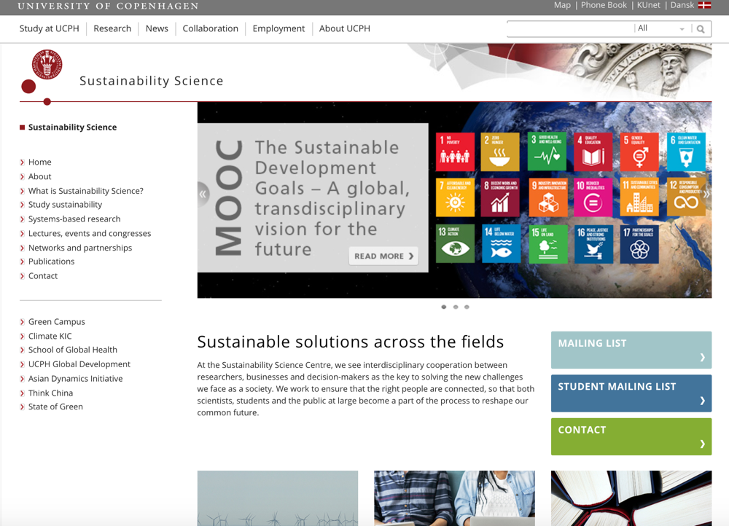

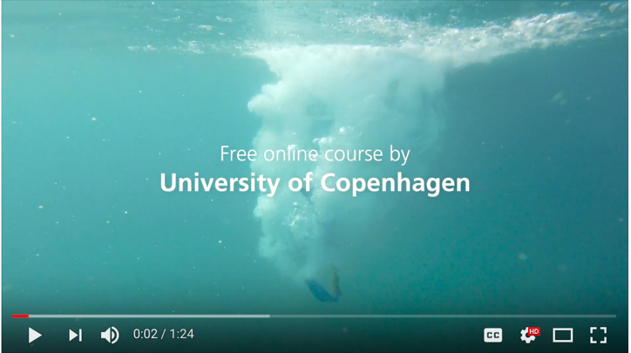

Launch
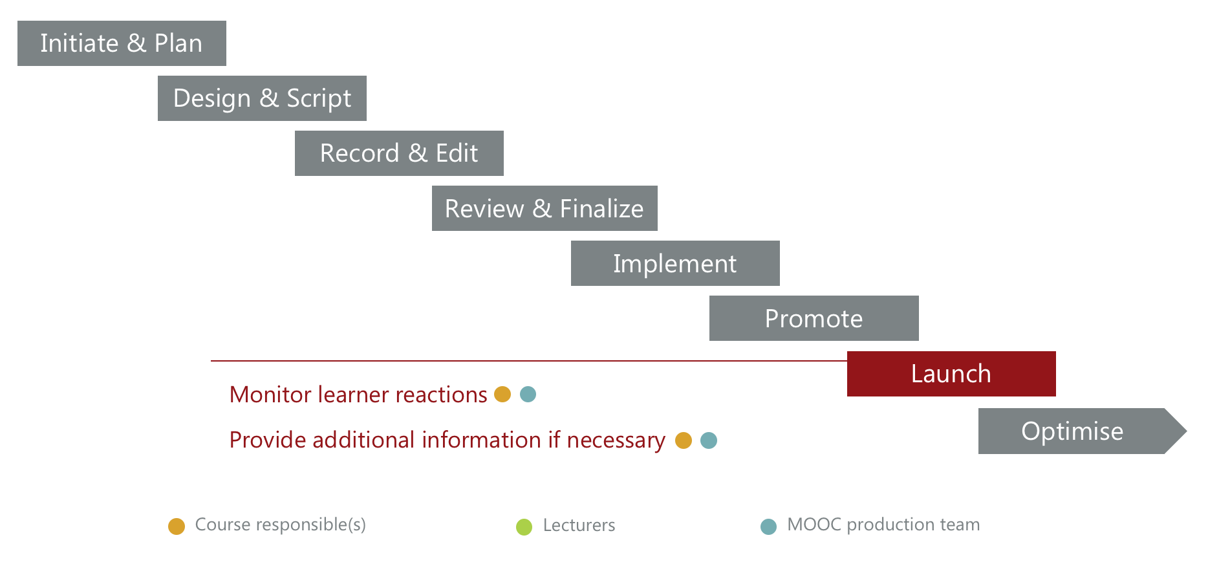
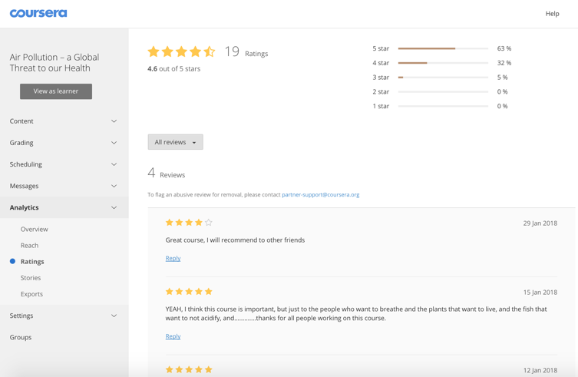
During the first course session, the course responsible(s) should monitor the learner reactions closely. On Coursera, you can find data on how many learners you reach, ratings, reviews, learner stories, reporting of issues, and questions raised in the course discussion forums. If relevant, give additional information or adjust quizzes and informational texts in the course.
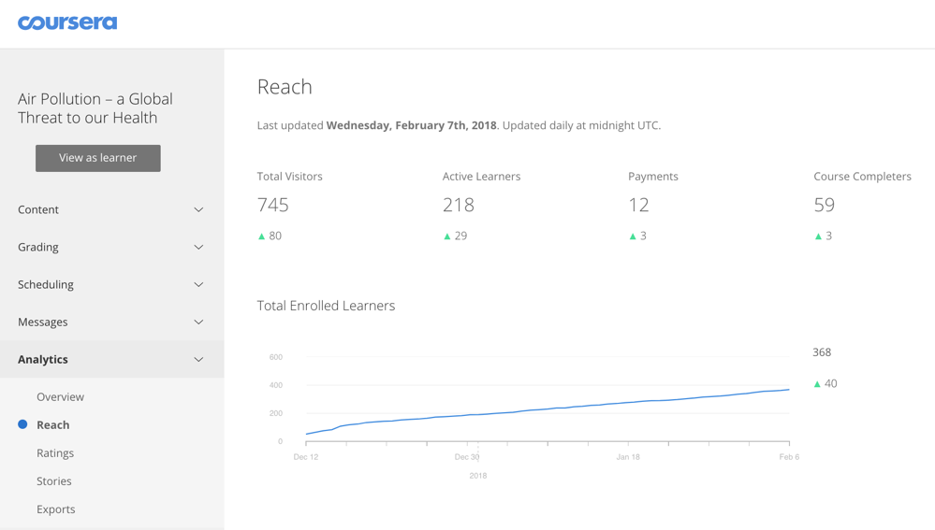

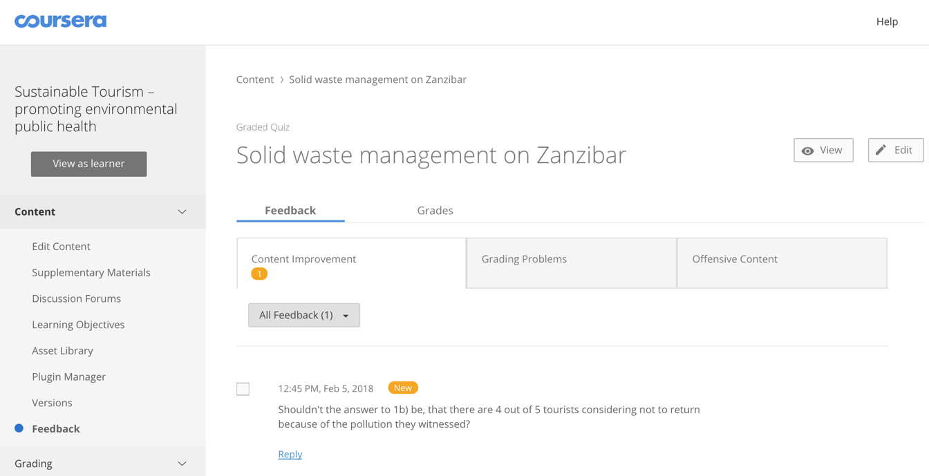

Optimize

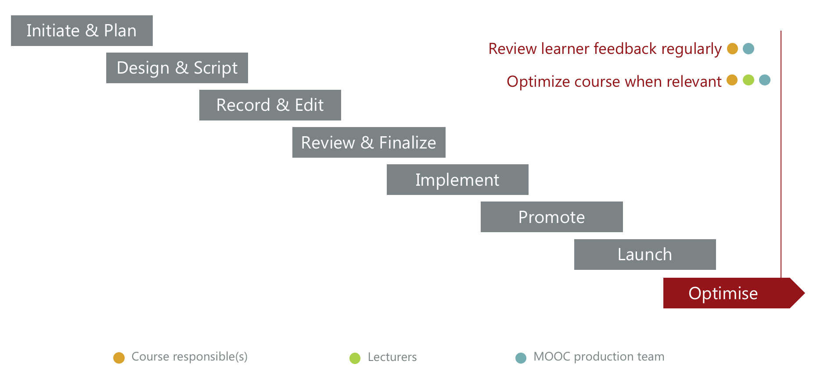

Review learner feedback regularly
After the first session with learner feedback and adjustments, you can go from close monitoring of learner feedback to reviewing learner feedback regularly. The MOOC Unit will also keep an eye on the learner feedback regularly and report issues to you if necessary. Coursera is responsible for any technical issues.

Optimse course when relevant
The learner community that builds up around your course is highly knowledgeable and interested in your field. Often, the learners provide good suggestions for improving the course – or interesting new material that you might want to add. Some issues can be fixed with little effort, directly in the course room. If you want to change video lectures, it requires more work.

Your learner community
Finally, with the learner community you have around a MOOC, you have direct access to people from all over the world who are interested in your field. This is a great opportunity to send out relevant information about study programmes, summer courses, conferences etc.

We look forward to developing more great MOOCs. If you have any questions, don’t hesitate to contact us:
MOOC Unit
University of Copenhagen
CSS Campus
Øster Farimagsgade 5, building 24.2, PO Box 2099
DK-1014 Copenhagen K
Denmark
Contact
Anne-Marie Mosbech
anne-marie@sund.ku.dk

